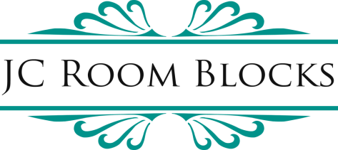
Hotel Comparison Report
Prepared for Birch/Kowalski Wedding
May 14, 2027 – May 16, 2027
Grand Bohemian Hotel Asheville
11 Boston Way
Asheville, NC 28803


#18 of 28 Hotels in Asheville

Special Negotiated Group Rates:
Room Type | Offered Rate | Regular "Rack" Rate
Premier Two Queen Mountain View Suite with Balcony and Kitchenette | $389 | $599
Classic King | $339 | $529
*Rates are per night and are based on s/d occupancy
*Rates do not include taxes and fees
Hotel Features:
• On-site restaurant & bar – Red Stag Grill
• Art gallery
• Fitness center
• Valet parking $35 per car, per night (subject to change)

Concessions:
• Complimentary Wi-Fi
• Complimentary gift bag distribution at the front desk (non-personalized)

Contracting Option:
• Hotel can offer 10 rooms per night on a courtesy agreement
• Courtesy Agreement - NO financial responsibility to client

Distance from Biltmore Estate: 0.2 miles
Cut-off Date: (last date for guests to book at the group rate): 30 days prior to arrival, by April 14, 2027

The Radical
95 Roberts Street
Asheville, NC 28801


TripAdvisor rating not verified - newer hotel; ranking not available

Special Negotiated Group Rates:
Room Type | Offered Rate | Regular "Rack" Rate
King Studio | $279 | $409
Double Queen Studio | $289 | $419
*Rates are per night and are based on s/d occupancy
*Rates do not include taxes and fees
Hotel Features:
• Rooftop restaurant and bar – Golden Hour
• On-site cafe
• Fitness center
• Self-parking $25 per car, per night (subject to change)

Concessions:
• Complimentary Wi-Fi
• Complimentary welcome drink at check-in

Contracting Option:
• 90% Attrition - Client financially responsible for 90% of the contracted room block
• Minimum of 10 rooms contracted per night required

Distance from Biltmore Estate: 1.8 miles
Cut-off Date: (last date for guests to book at the group rate): 60 days prior to arrival, by March 15, 2027

JC Room Blocks, P.O. Box 2661, Canyon Country, CA 91386 / 818-406-2351 / Info@JCRoomBlocks.com / www.JCRoomBlocks.com

